Descriptive Analytics on Apple(AAPL) Stock Data

An independent project by: Antonius Jose

# Objective

The objective of this research is to analyze and visualize the potential risk, return, and trend behavior of Apple Inc. (AAPL) stock over the selected 2010 period. The study aims to identify price movement patterns, evaluate short-term and long-term trends, and measure volatility levels to provide insights into the stock’s performance.

# Dataset

| Column | Definition | Data Type |
| --- | --- | --- |
| Date | The trading day | object |
| Open | The first share price traded during the trading day | float64 |
| High | The maximum share price reached during the trading day | float64 |
| Low | The minimum price reached during the trading day | float64 |
| Close | The final share price traded during the trading day | float64 |
| Adj. Close | The closing share price after adjustments based on dividends and stock splits have been made | float64 |
| Volume | The total amount of shares traded during the trading day | int64 |

# Process

## Data Cleaning

The first step in this research is data cleaning. I used .shape, .head and .info to see the overview of the dataset and verify if all is as it should be. Following that, I dropped all the null and duplicate values, and ensured that all numeric columns will be read as an integer instead of text.

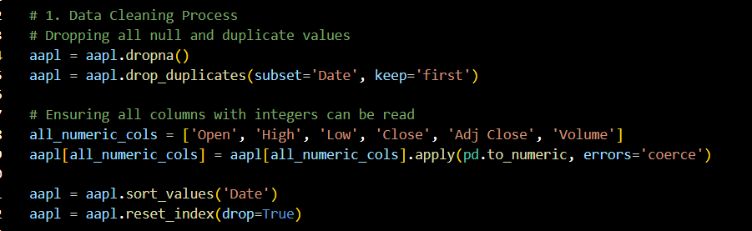

## Calculations

1. Daily Returns

Daily returns represent the change in closing prices between days, it measures daily profitability for an investor based on how much they have gained or lost.

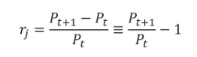

1. Moving Average

Moving average calculates the average closing price for the stock in the last x amount of days, and is used to identify the momentum or trends of the stock. In this case, I used 7 and 21 to measure short term and medium term market trends.

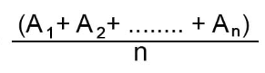

1. Rolling Volatility

Rolling volatility measures the risk of a stock price based on the amount of fluctuations it experiences in the span of x amount of time. It is calculated by finding the standard deviation of daily returns in the last x amount of time, in this case, I used 21 days.

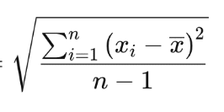

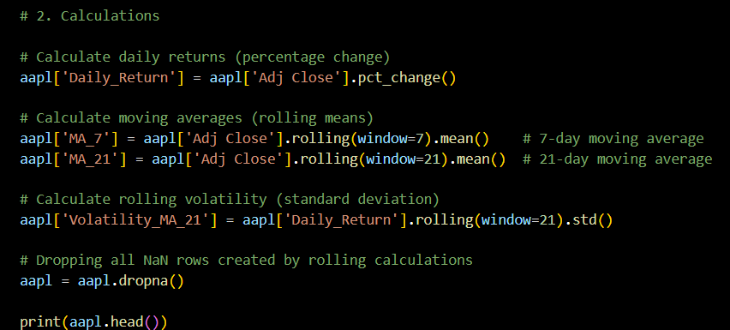

## Graphs & Analysis

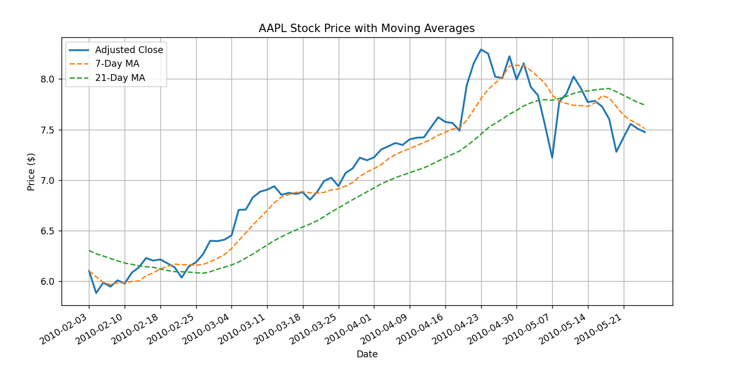

The graph illustrates Apple’s adjusted closing price alongside two moving averages: a 7-day (short-term) and a 21-day (medium-term) moving average. This visualization provides a clear view of the stock’s trend and momentum over time. During the observed period, the price shows a clear steady upward movement from February through early May, with the 7-day moving average frequently positioned above the 21-day average. This indicates that the short-term momentum is stronger than the long-term trend. By late May, the short-term line begins to converge downward and intersects with the medium-term line, suggesting a possible slowdown or correction.

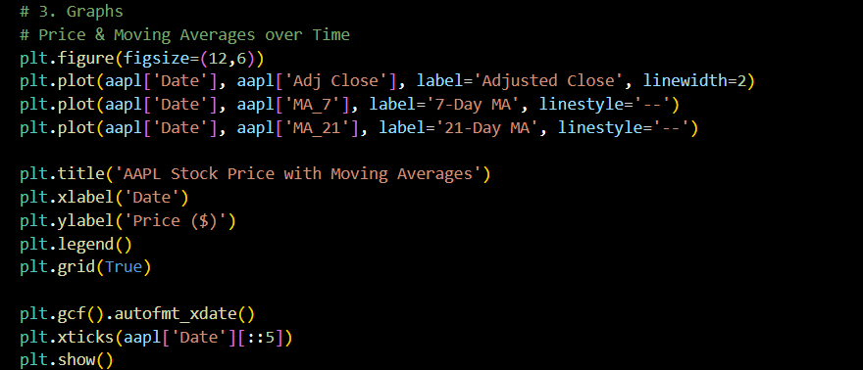

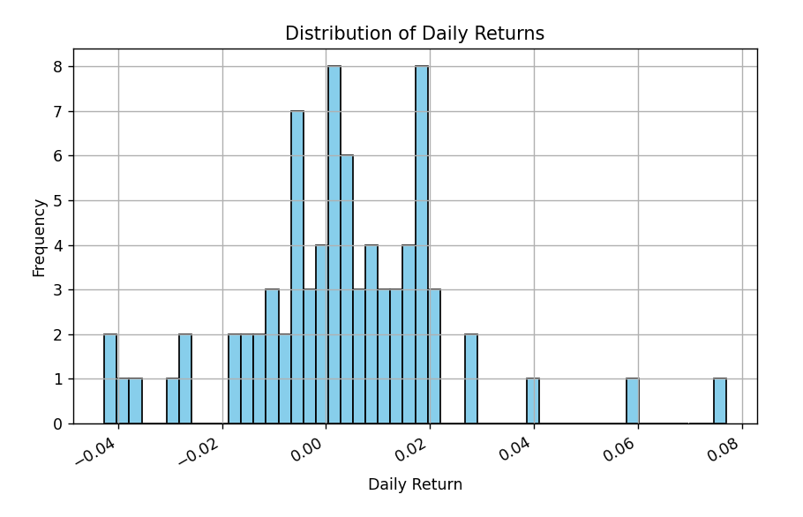

The graph shows the frequency of Apple’s daily price changes expressed as percentages. The data reveals that most daily returns are placed between 0% and 2%, suggesting that Apple experienced relatively small but stable fluctuations during this period. While there are a few extreme observations, the overall distribution is slightly right-skewed. The asymmetry of the graph also suggests that there were more frequent small gains rather than large losses which is favorable for investors.

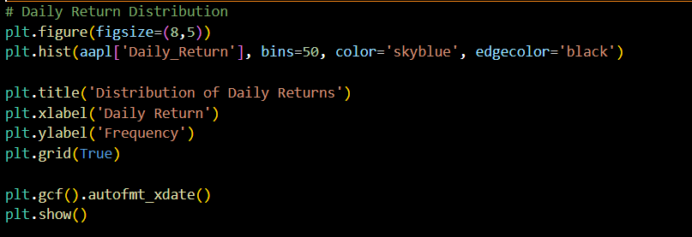

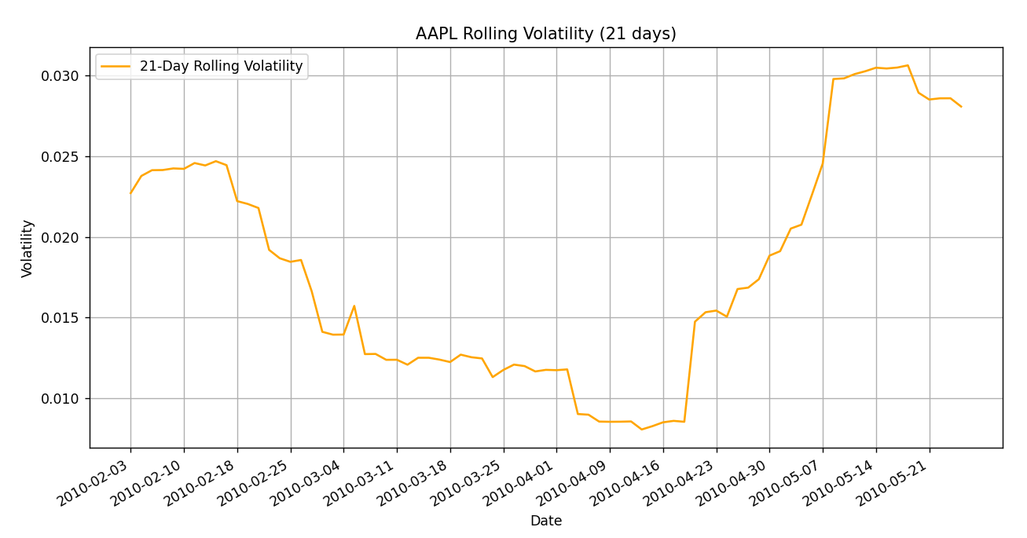

The final graph, Rolling Volatility (21 Days), tracks the standard deviation of daily returns within a moving 21-day window to illustrate how the stability of the market’s perception of the stock was. Early in the year, the graph reveals a moderate level of volatility, followed by a noticeable drop in March and April, where it was stable. However, volatility began to climb again sharply in late April, possibly suggesting uncertainty or external events affecting investors such as Apple’s acquisition of Siri Inc. on 28 April 2010.

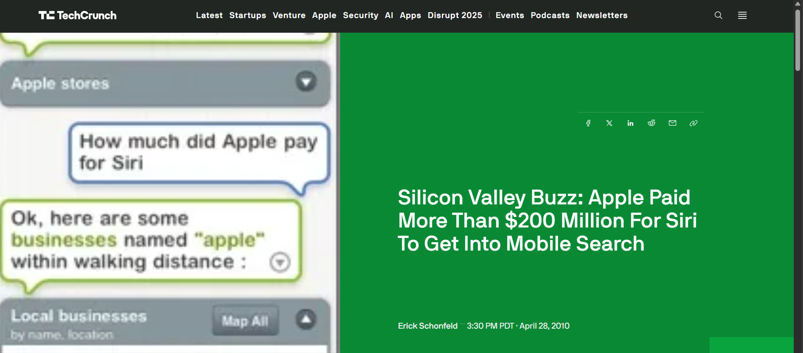

E. Schonfeld, “Silicon Valley Buzz: Apple Paid More Than $200 Million For Siri To Get Into Mobile Search,” *TechCrunch*, Apr. 28, 2010. Available: <https://techcrunch.com/2010/04/28/apple-siri-200-million/>

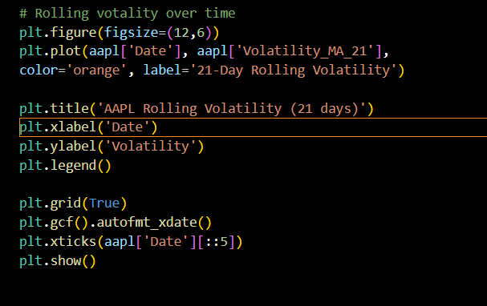

# Conclusion

From the analysis and visualizations, the data shows that Apple’s stock performance in early 2010 was overall positive, with a clear upward trend supported by both short-term and medium-term moving averages. The 7-day moving average staying above the 21-day average for most of the observed period indicates the presence of consistent short-term growth. However, by late May, the two lines converged which could suggest a potential slowdown or a short correction in price momentum.

The distribution of daily returns suggests that Apple’s stock experienced mostly small and stable price movements, with most daily changes falling between 0% and 2%. This stability and the slight right-skewed distribution imply that the stock was generating frequent small gains rather than sharp losses which would be a positive sign for both investors and short-term traders.

The rolling volatility graph provides further insight into the risk behavior of the stock. The volatility was relatively moderate through the early months, then declined in March and April, showing a period of market stability. However, the sharp increase in volatility in late April indicates the occurrence of an event that affected the sentiment of investors. Upon doing more research, I believe that it is possibly linked to Apple’s strategic move of acquiring Siri Inc. for around $200 million, the launch of the first iPad with 3G capability, and rumors of the company wanting to build its own search engine. These developments likely created uncertainty for investors for the future of Apple, possibly causing the rise in volatility.

Overall, the results suggest that Apple had maintained strong short-term performance and moderate risk during this period, with the company being in a state of preparation for future expansions and innovation.